

 Know Your TX – Dissecting a Transaction

* **Objective/Aim:**  
    
   To study and understand how a blockchain transaction works by creating and examining a transaction on the Sepolia Ethereum test network.  
    
    
  **Apparatus/Software Used:**
* Desktop or Laptop
* Internet Browser
* MetaMask wallet configured to Sepolia Test Network
* Sepolia Test ETH (obtained from a faucet)
* Sepolia Etherscan for transaction verification

**Theory/Concept:**

**What Is an Ethereum Transaction (TX)?**

***An Ethereum transaction is a digitally signed command that transfers ETH or interacts with a contract, recorded permanently on the blockchain.***

**Important Transaction Components:**

* ***Transaction Hash (TX Hash): A unique code assigned to each transaction.***
* ***Sender Address: The wallet address initiating the transaction.***
* ***Receiver Address: The wallet or contract address receiving ETH.***
* ***Nonce: A counter showing the total transactions sent from a specific account.***
* ***Value: The amount of ETH sent in the transaction.***
* ***Timestamp: The date and time when the transaction was processed.***
* ***Status: Indicates if the transaction was successful or failed.***



**Procedure:**

|  |  |  |  |
| --- | --- | --- | --- |
|  |  |  |  |
|  |  |  |  |
|  |  |  |  |
|  |  |  |  |
|  |  |  |  |
|  |  |  |  |
|  |  |  |  |

**Step 1: . Open MetaMask and switch the active network to Sepolia Test Network**

**Step 2: Go to a Sepolia faucet website, paste your Sepolia wallet address, and request test ETH.**

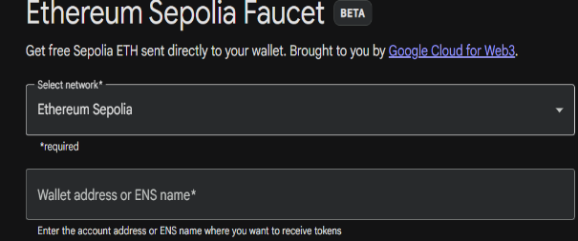

**Step 3: After receiving ETH, click Send in MetaMask, enter the recipient’s Sepolia address, specify the amount, and confirm the transaction.**

**Step 4: Once the transaction is confirmed, open the details in Sepolia Etherscan using the provided link in MetaMask.**

**Step 5: Search your wallet address in Etherscan to view and analyze all transaction details.**

**Observation Table:**

1: The wallet address was successfully entered on the Sepolia faucet page.

2: The faucet processed the request, and test ETH was sent.

3: The Sepolia ETH appeared in the MetaMask wallet after a short delay.

4: The transaction appeared on Sepolia Etherscan with a “Success” status.



